**Feature Scaling (FE)**

**What is One Hot Encoding:** whenever we have nominal categorical data then we split the categories of that feature into columns i.e against each category we create a column and assign them 1 and 0.

**Note:** multiclonality is process in which we remove a column from those which are created with the help of one hot encoding.

**Note:** when ever we got lot numbers of dimensions due to one hot encoding then what we do is. We only keep most frequent categories and convert less frequent categories into a new single category.\

**Pipelines**

Pipelines chains together multiple steps so that the output of each step is used as input to the next step. Pipelines makes it easy to apply the same preprocessing to train and test.

Always use pipeline because it is very useful in the prospective of production of the software. Code in (Feature scaling folder)

**Note:** Project life cycle = (**[Data Preprocessing]**EDA -> Feature Engineering-> Feature Scaling)->(**[Model Training]**Model creation) -> model deployment

* **Data preprocessing** has object of Transformers: which are used to for feature engineering. i.e scaling the feature e.g StandardScaler, MinMaxScaler which transform the feature mean = 0 and standard deviation = 1.
* **Model Training** has object of Model: which are used to train the model. E.g Linear Regression, Logistic Regression, Decision Tree.

**Note: fit(), transform() , fit_transform() and predict() methods in scikit learn differences.**

|  |  |
| --- | --- |
| **Transformer** | **Model** |
| For training data we do fit and transform | for training data we do fit |
| For Test data we do transform only | For test data we do predict |

**Fit ():** when we apply fit method on training data it actually only computes the standardization whose formula is = Xi – mean / standard deviation

**Transform ():** when we apply transform it actually apply the standardization on whole of the feature values. And there mean = 0, and SD = 1.

**Fit_tranform():** does both the things at same time.

**Predict ():** is used with model to predict on test or new data.

**Feature Transformation (FE)**

**Note**: What happens after applying the transformation? Why your model improves?

Ans is that the Probability Density (PDF) function is converted into normal distribution.

In Scikit library there are 3 mathematical transformers

1. **Function Transformer**.
   1. Log transformer.
   2. Reciprocal transformer.
   3. Square root transformer.
   4. Custom.
2. **Power Transformer**.
   1. Box-Cox
   2. Yeo-Jhonson
3. **Quantile Transformer.**

**How to find if data is normal or not?**

You can use sns.distplot() of seaborn or pd.skew() of pandas library to check the normal distribution.

**Note: Most reliable is QQplot which is a statistical method of scipy.stats library**.

1. Log transform (Log): you can take the log values of your feature base2 or base10 what it does is. It transforms your unequal distributed data to nearly normal distribution. It can be used when your data is right skewed.
2. Reciprocal transform (1/ x): It makes the smaller value greater and vice versa.
3. Square root (root (x2)): Applied on left skewed.

**Power Transformer**

1. 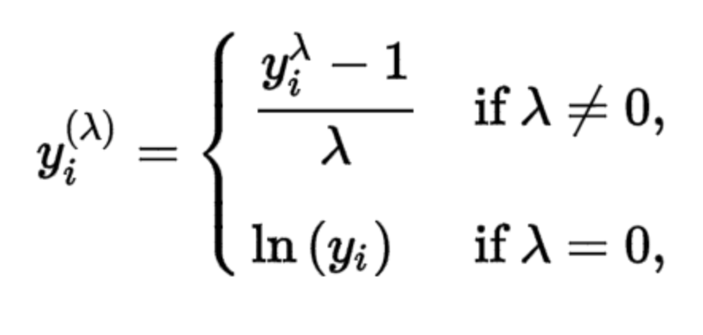**Box-Cox Transformer:**

With this formula you can transform given distribution to normal distribution.

The exponent here is a variable called lambda (λ) that varies over the range of -5 to 5 and in the process of searching we examine all the values of (λ). Finally we choose the optimal value (resulting in the best approximation to a normal distribution) for your vaiables.

1. 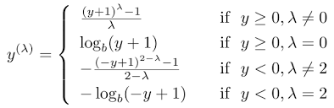**Yeo-Jhonson Transform:**

This transformation is somewhat of an adjustment to the Box-Cox transformation, by which we can apply it to negative numbers.

**Note**: When you are working on regression problem then you must see the distribution of data. Normally real-world data is not in normal distribution from. So when your data contains non-negative values than apply Box-Cox if it contains negative values then apply Yeo-Jhonson transformer.